CCNA 1 Chapter 5 activity: VLSM to increase security and performance
In this activity you are required to;
- Create an efficient VLSM design given the requirements.
- Assign appropriate addresses to interfaces and document the addresses.
- Cable a network according to the Topology Diagram.

You will create a small network that requires connecting network devices and configuring host computers for basic network connectivity.
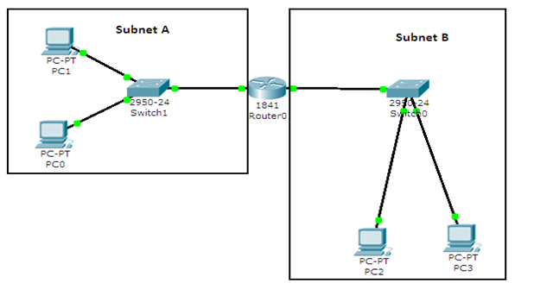
Figure 1: Network Scenario
Task 1: Design the Logical LAN Topology.
Given an IP address and mask of 10.10.1.0 / 24 (address / mask), design a VLSM IP addressing scheme that satisfies the following requirements:

Subnet | Number of Hosts
Subnet A | 8
Subnet B | 56
Table 1: Requirements

The 0th subnet is used. All work must be shown.

Subnet B

Specification | Student  Input
Network Address | 10.10.1.0
Subnet Mask (Decimal) | 255.255.255.192
CIDR Notation | /26
First IP Host address | 10.10.1.1
Last IP Host address | 10.10.1.62
Number of usable hosts in subnet | 64-2=62
Broadcast address | 10.10.1.63
Table 2: Subnet B

Subnet A
Specification | Student  Input
Network Address | 10.10.1.64
Subnet Mask (Decimal) | 255.255.255.240
CIDR Notation | /28
First IP Host address | 10.10.1.65
Last IP Host address | 10.10.1.78
Number of usable hosts in subnet | 16-2=14
Broadcast address | 10.10.1.79
Table 3: Subnet A

Host computers will use the FIRST IP address in the subnet. The network router will use the LAST network host address.

Write down the IP address information for each device:

Device | IP address | Mask | Gateway
PC 0 | 10.10.1.65 | 255.255.255.240 | 10.10.1.78
PC 1 | 10.10.1.66 | 255.255.255.240 | 10.10.1.78
Router0-Fa0/0 | 10.10.1.78 | 255.255.255.240 | No Gateway
PC 2 | 10.10.1.1 | 255.255.255.192 | 10.10.1.62
PC 3 | 10.10.1.2 | 255.255.255.192 | 10.10.1.62
Router0-Fa0/1 | 10.10.1.62 | 255.255.255.192 | No Gateway
Table 4: Interface IP address information

Task 2: Configure the Logical Topology.
Open the file called Chapter 5 Topology.pka on the network drive.
Step 1: Configure host computers with correct IP configuration
Step 2: Configure Router0.

Configuration tasks for Router0 include the following:

Task | Specification
Router name | Router0 (Already set)
Console Password | Cisco (Already set)
Router0 interface Fa0/0 | - set IP address and Mask
Router0 interface Fa0/1 | - set IP address and Mask
Table 5: Router configuration details
Hint: Use the commands sheet to help configure the router
Task 3: Verify network connectivity.
Network connectivity can be verified with the ping command.
Can PC 3 be pinged from PC 1? Yes, they are on the same router.

